**Electronic supplementary information**

**INFLUENCE OF aliphatic substituents on the  
properties of** **2,1,3-benzothiadiazole-based  
luminophores**

D. E. Stakanova, V. V. Popova, E. A. Svidchenko,  
O. V. Borshchev,* and S. A. Ponomarenko

*Enikolopov Institute of Synthetic Polymeric Materials, Russian Academy of Sciences,  
ul. Profsoyuznaya 70, Moscow, 117393 Russia*

**Table of contents**

1. Experimental section S2

1.1. Materials S2

1.2. Characterization S2

1.3. Synthesis S2

2. NMR spectra S6

3. Optical properties S16

4. Thermogravimetric analysis S18

5. References S19

**1. Experimental section**

**1.1. Materials**

2.5 M solution of *n*-butyllithium in hexane, potassium carbonate, bromine, 2-hexylthiophene, 2-octylthiophene, and 2-decylthiophene were obtained from Acros; tetrakis(triphenylphosphine)palladium(0) Pd(PPh3)4, 2-isopropoxy-4,4,5,5-tetramethyl-1,3,2-dioxaborolane (IPTMDOB) were obtained from Sigma-Aldrich. 4,7-*bis*(4-Bromophenyl)-2,1,3-benzothiadiazole [S1], 4,4,5,5-tetramethyl-2-(5-hexylthiophen-2-yl)-1,3,2-dioxaborolane [S2], 4,4,5,5-tetramethyl-2-(5-octylthiophen-2-yl)-1,3,2-dioxaborolane [S3], 4,4,5,5-tetramethyl-2-(5-decylthiophen-2-yl)-1,3,2-dioxaborolane [S4], and 4,4,5,5-tetramethyl-2-(thiophen-2-yl)-1,3,2-dioxaborolane [S5] were prepared according to the published procedures. THF was dried and purified by the standard techniques; toluene was distilled under an argon atmosphere; ethanol, sodium and potassium carbonate solutions were purged with argon for 30 min. All reactions, unless otherwise stated, were carried out under an argon atmosphere using anhydrous solvents. The solvents were removed under vacuum below 1 Torr at 40 °C.

Column chromatography was carried out using silica gel 60 0.04–0.063 mm (Macherey-Nagel). Thin layer chromatography (TLC) was performed using Sorbfil plates (Russia).

**1.2. Characterization**

The 1H NMR spectra were recorded on a Bruker WM250 SY (Germany) spectrometer (250.13 MHz) using the residual signal of CDCl3 (*δ* = 7.25 ppm) as an internal standard. The spectra were then processed using the ACD Labs software.

The GPC analysis was performed on a Shimadzu instrument with a RID10AVP refractometer and an SPD-M10AVP diode matrix as detectors using 7.8×300mm2 Phenomenex columns (USA) filled with the Phenogel sorbent with pore size of 500 Å and THF as an eluent.

The thermogravimetric analysis (TGA) was carried out in a dynamic mode in the temperature range of 30–700 °C using a Mettler Toledo TG50 system equipped with M3 microbalance allowing measuring the mass of samples in 0–150 mg range with 1 μg precision. The heating/cooling rate was 10 °C·min–1.

The absorption spectra of the luminophore solutions in THF were measured using a Shimadzu UV-2501PC spectrophotometer (Japan). The fluorescence spectra were measured using a FLUORAN-2 spectrofluorimeter (VNIIOFI, Russia). Standard 10×10 mm quartz cells were used to measure the fluorescence spectra of solutions. The fluorescence quantum yield was measured using the method of optically diluted solutions. Solutions of rhodamine 6G in ethanol (QYF = 0.95) or РОРОР in cyclohexane (QYF = 0.93) with optical density ε×c×l≤0.1 were used as fluorescent standards.

The measurements of the quantum yield and fluorescence spectra of crystalline films on a quartz substrate were carried out in an integrating sphere made of highly reflective polytetrafluoroethylene. Crystalline tetraphenylbutadiene was used to calibrate the sphere.

**1.3. Synthesis**

**4,7-*bis*(4-Bromophenyl)**-**2,1,3-benzothiadiazole.** A solution of Br2 (12 mL, 0.219 mol) in chloroform (12 mL) was slowly added to a solution of I2 (0.12 g, 0.00048 mol) and 4,7-diphenyl-2,1,3-benzothiadiazole (2.75 g, 0.00955 mol) in chloroform (35 mL). The reaction mixture was stirred at room temperature for 20 h, which was accompanied by the formation of a precipitate. The precipitate was filtered off and sequentially washed with 5% aq. sodium thiosulfate, water, and acetone. The crude product was purified by recrystallization from toluene to give 2.5 g of the target compound as yellow crystals. Yield: 59%. 1H NMR (CDCl3, *δ*, ppm): 7.67 (dt, *J*1 = 2.44 Hz, *J*2 = 8.55 Hz, 4H), 7.79 (s, 2H), 7.85 (dt, *J*1 = 2.44 Hz, *J*2 = 8.55 Hz, 4H).

**4,4,5,5-Tetramethyl-2-(5-hexylthiophen-2-yl)-1,3,2-dioxaborolane (Hex-T-B-pin).** 2.5 M *n*-butyllithium in hexane (16 mL, 0.0392 mol) was added dropwise to a cooled solution of 2-hexylthiophene (6 g, 0.0356 mol) in THF (120 mL), maintaining the temperature at –78 °C. The reaction mixture was stirred at this temperature for 1 h. Then IPTMDOB (7.85 g, 0.0422 mol) was added, and the reaction mixture was allowed to heat to room temperature. The resulting mixture was extracted with diethyl ether. The organic phase was washed with distilled water three times. The solvents were removed on a rotary evaporator, and the product obtained (colorless liquid) was dried under vacuum. According to the GPC data, the purity of the product was 90%, which allowed for using it in the subsequent synthesis without purification. Yield: 9.62 g (92%). 1H NMR (CDCl3, *δ*, ppm): 0.85 (t, *J* = 6.41 Hz, 3H), 1.27–1.34 (overlapping signals, 18H), 1.67 (m, Hz, 2H), 2.84 (m, 2H), 6.85 (d, *J* = 3.81 Hz, 1H), 7.46 (d, *J* = 3.81 Hz, 1H).

**4,4,5,5-Tetramethyl-2-(5-octylthiophen-2-yl)-1,3,2-dioxaborolane (Oct-T-B-pin).** 2.5 M *n*-butyllithium in hexane (10 mL, 0.0245 mol) was added dropwise to a cooled solution of 2-octylthiophene (4.89 g, 0.0249 mol) in THF (100 mL), maintaining the temperature at –78 °C. The reaction mixture was stirred at this temperature for 1 h. Then IPTMDOB (5.44 g, 0.0288 mol) was added, and the reaction mixture was allowed to heat to room temperature. The reaction mixture was extracted with diethyl ether, and the organic phase was washed with distilled water three times. The solvents were removed on a rotary evaporator, and the product was dried under vacuum. According to the GPC data, the purity of the product (colorless liquid) was 91%, which allowed for using it in the subsequent synthesis without purification. Yield: 7.9 g (98%). 1H NMR (CDCl3, *δ*, ppm): 0.87 (t, *J* = 6.5 Hz, 3H), 1.22–1.27 (overlapping signals, 10H), 1.33 (s, 12 H), 1.66 (m, 2H), 2.85 (m, 2H), 6.85 (d, *J* = 3.4 Hz, 1H), 7.46 (d, *J* = 3.4 Hz, 1H).

**4,4,5,5-Tetramethyl-2-(5-decylthiophen-2-yl)-1,3,2-dioxaborolane (Dec-T-B-pin).** 2.5 M *n*-butyllithium in hexane (10 mL, 0.0245 mol) was added dropwise to a solution of 2-decylthiophene (5 g, 0.0223 mol) in THF (100 mL), maintaining the temperature at –78 °C. The reaction mixture was stirred at this temperature for 1 h. Then IPTMDOB (4.8 g, 0.0258 mol) was added, and the reaction mixture was allowed to heat to room temperature. The reaction mixture was extracted with diethyl ether, and the organic phase was washed with distilled water three times. The solvents were removed on a rotary evaporator, and the product was dried under vacuum. According to the GPC data, the purity of the product was 89%, which allowed for using it in the subsequent synthesis without purification. Yield: 7.5 g (96%). 1H NMR (CDCl3, *δ*, ppm): 0.88 (t, *J* = 6.5 Hz, 3H), 1.23–1.27 (overlapping signals, 14H), 1.32 (s, 12H), 1.67 (m, 2H), 2.84 (m, 2H), 6.84 (d, *J* = 3.36 Hz, 1H), 7.45 (d, *J* = 3.36 Hz, 1H).

**4,4,5,5-Tetramethyl-2-(thiophen-2-yl)-1,3,2-dioxaborolane (T-B-pin).** 2-Bromothiophene (9.9 g, 0.0611 mol) was dissolved in THF (80 mL) and slowly added dropwise to magnesium turnings (1.56 g, 0.0642 mol) in THF (20 mL). The stirred reaction mixture was refluxed for 2 h. After cooling to room temperature, IPTMDOB (12.4 g, 0.0642 mol) and THF (30 mL) were added. The resulting mixture was stirred at room temperature for 2 h and diluted with diethyl ether. The solution obtained was washed with distilled water three times. The organic layer was separated and evaporated to dryness on a rotary evaporator. The residue obtained was dried under vacuum to give 10.98 g of the target product as a brownish solid. Yield: 85%. 1H NMR (CDCl3, *δ*, ppm): 1.35 (s, 12H), 7.21 (d, *J* = 3.8 Hz, 1H), 7.67 (d, *J* = 3.8 Hz, 1H).

**4,7-*bis*[4-(5-Hexylthiophen-2-yl)phenyl]-2,1,3-benzothiadiazole (Hex-T-Ph-BTD).** A stirred mixture of 4,7-bis(4-bromophenyl)-2,1,3-benzothiadiazole (0.723 g, 0.0025 mol), **Hex-T-B-pin** (1.27 g, 0.0036 mol), Pd(PPh3)4 (0.092 g, 0.00007 mol), 2M aq. K2CO3 (4 mL), ethanol (4 mL), and toluene (60 mL) was refluxed for 30 h. The reaction course was monitored using GPC. After the reaction completion, the resulting mixture was cooled to room temperature, the aqueous phase was removed with a syringe, the organic phase was concentrated and filtered through a thin layer of silica gel in toluene, which was evaporated on a rotary evaporator. The crude product was purified by recrystallization from cyclohexane to give **Hex-T-Ph-BTD** as orange crystals. Yield: 0.425 g (43%). 1H NMR (CDCl3, *δ*, ppm): 0.90 (t, *J* = 7.02 Hz, 6H), 1.29–1.45 (overlapping signals, 12H), 1.72 (m, 4H), 2.84 (m, 4 H), 6.77 (d, *J* = 3.35 Hz, 2H), 7.21 (d, *J* = 3.35 Hz, 2H), 7.71 (d, *J* = 8.55 Hz, 4H), 7.82 (s, 2H), 7.97 (d, *J* = 8.55 Hz, 4H). 13C NMR (CDCl3, *δ*, ppm): 154.10, 146.18, 141.13, 135.82, 134.83, 132.68, 129.51, 127.57, 125.54, 125.02, 123.03, 31.46, 30.22, 28.68, 22.42, 13.98, 13.85. Anal. Calcd for C38H40N2S3 : C, 73.51; H, 6.49; S, 15.49. Found: C, 73.63; H, 6.54; S 15.35%.

**4,7-*bis*[4-(5-Octylthiophen-2-yl)phenyl]-2,1,3-benzothiadiazole (Oct-T-Ph-BTD).** A stirred mixture of 4,7-bis(4-bromophenyl)-2,1,3-benzothiadiazole (0.82 g, 0.0018 mol), **Oct-T-B-pin** (1.8 g, 0.0046 mol), Pd(PPh3)4 (0.07 g, 0.00003 mol), 2M aq. K2CO3 (5 mL), ethanol (5 mL), and toluene (80 mL) was refluxed for 20 h. The reaction course was monitored using GPC. After the reaction completion, the resulting mixture was cooled to room temperature, the aqueous phase was removed with a syringe, the organic phase was concentrated and filtered through a thin layer of silica gel in toluene, which was evaporated on a rotary evaporator. The crude product was purified by recrystallization from toluene to give **Oct-T-Ph-BTD** as orange crystals. Yield: 0.716 g (57%). 1H NMR (CDCl3, *δ*, ppm): 0.89 (t, *J* = 6.72 Hz, 6H), 1.22–1.46 (overlapping signals, 20H), 1.72 (m, 4H), 2.84 (m, 4H), 6.78 (d, *J* = 3.66 Hz, 2H), 7.21 (d, *J* = 3.66 Hz, 2H), 7.73 (d, *J* = 8.24 Hz, 4H), 7.81 (s, 2H), 7.98 (d, *J* = 8.24 Hz, 4H). 13C NMR (CDCl3, *δ*, ppm): 154.11, 146.18, 141.14, 135.82, 134.84, 132.70, 129.51, 127.56, 125.54, 125.01, 123.03, 31.73, 31.48, 30.21, 29.20, 29.07, 29.02, 22.49, 13.85. Anal. Calcd for C42H48N2S3: C, 74.51; H, 7.15; S, 14.21. Found: C, 75.02; H, 7.17; S 14.19%.

**4,7-*bis*[4-(5-Decylthiophen-2-yl)phenyl]-2,1,3-benzothiadiazole (Dec-T-Ph-BTD).** A stirred mixture of 4,7-bis(4-bromophenyl)-2,1,3-benzothiadiazole (0.9 g, 0.0021 mol), **Dec-T-B-pin** (1.8 g, 0.0051 mol), Pd(PPh3)4 (0.107 g, 0.0001 mol), 2M aq. K2CO3 (5 mL), ethanol (5 mL), and toluene (100 mL) was refluxed for 20 h. The reaction course was monitored using GPC. After the reaction completion, the resulting mixture was cooled to room temperature, the aqueous phase was removed with a syringe, the organic phase was concentrated and filtered through a thin layer of silica gel in toluene, which was evaporated on a rotary evaporator. The crude product was purified by recrystallization from cyclohexane and THF to give **Dec-T-Ph-BTD** as orange crystals. Yield: 0.585 g (39%). 1H NMR (CDCl3, *δ*, ppm): 0.88 (t, *J* = 6.72 Hz, 6H) 1.22–1.46 (overlapping signals, 32H), 1.72 (m, 4H), 2.84 (m, 4H), 6.78 (d, *J* = 3.66 Hz, 2H), 7.21 (d, *J* = 3.66 Hz, 2H), 7.73 (d, *J* = 8.24 Hz, 4H), 7.81 (s, 2H), 7.98 (d, *J* = 8.24 Hz, 4H). 13C NMR (CDCl3, *δ*, ppm): 154.12, 146.19, 141.14, 135.83, 134.85, 132.71, 129.51, 127.57, 125.55, 125.01, 123.03, 31.76, 31.48, 30.21, 29.45, 29.41, 29.23, 29.16, 29.01, 22.50, 13.85. Anal. Calcd for C46H56N2S3: C, 75.36; H, 7.70; S, 13.12. Found: C, 75.45; H, 7.73; S 13.09%.

**4,7-*bis*[4-(Thiophen-2-yl)phenyl]-2,1,3-benzothiadiazole (T-Ph-BTD).** A stirred mixture of 4,7-bis(4-bromophenyl)-2,1,3- benzothiadiazole (1 g, 0.0022 mol), **T-B-pin** (1,183 g, 0.0056 mol), Pd(PPh3)4 (0.055 g, 0.00004 mol), 2M aq. K2CO3 (6 mL), ethanol (6 mL), and toluene (100 mL) was refluxed for 28 h. The reaction course was monitored using GPC. After the reaction completion, the resulting mixture was cooled to room temperature, the aqueous phase was removed with a syringe, the organic phase was concentrated and filtered through a thin layer of silica gel in toluene, which was evaporated on a rotary evaporator. The crude product was purified by column chromatography (eluent: cyclohexane–toluene (2:1 *v/v*)) to give **T-Ph-BTD** as yellowish crystals. Yield: 0.086 g (15%). The NMR spectra are in good agreement with the literature data [S5]. 1H NMR (CDCl3, *δ*, ppm): 7.99 (d, *J* = 8.55 Hz, 4H), 7.82 (s, 2H), 7.79 (d, *J* = 8.85 Hz, 4H) 7.41 (dd, *J*1 = 3.66, *J*2 = 1.22 Hz, 2H) 7.33 (dd, *J*1 = 4.89, *J*2 = 1.22 Hz, 2H), 7.12 (m, 2H).

**2. NMR spectra**

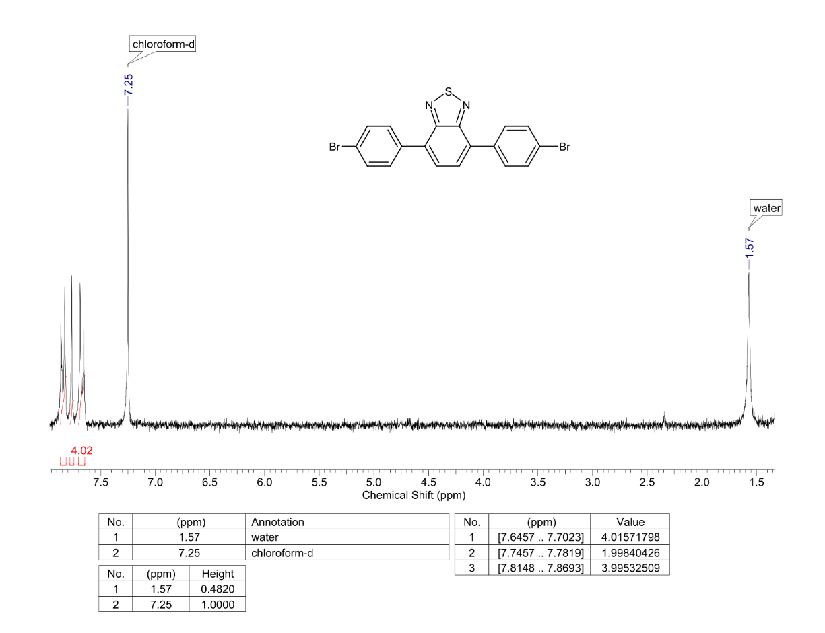

**Figure S1.** 1H NMR spectrum of **Br-Ph-BTD**.

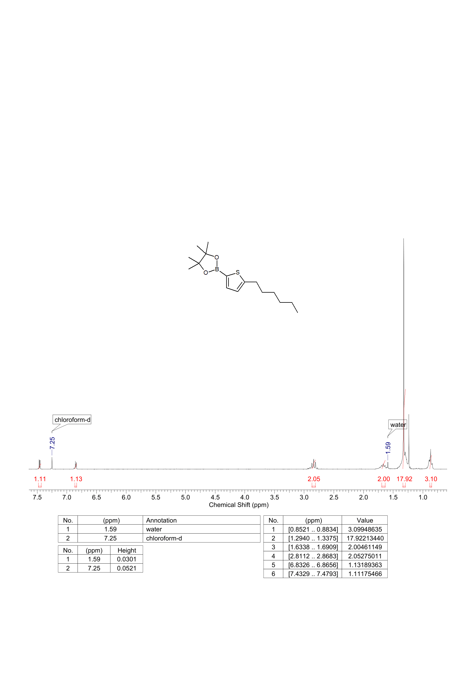

**Figure S2.** 1H NMR spectrum of **Hex-T-B-pin**.

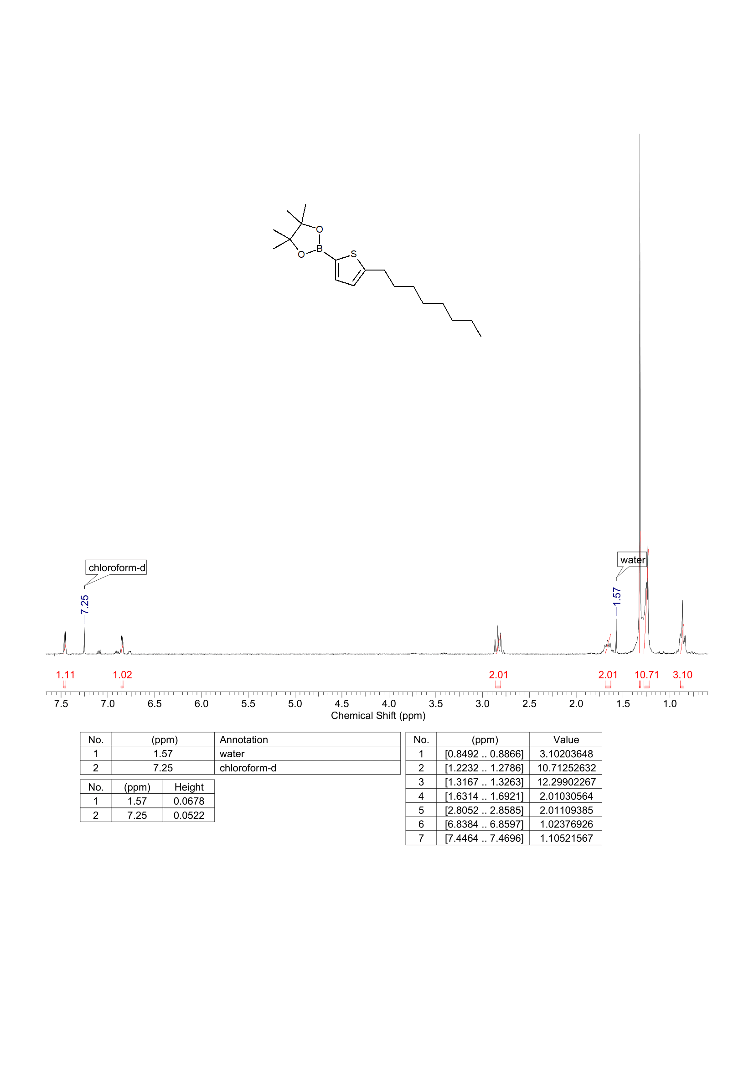

**Figure S3.** 1H NMR spectrum of **Oct-T-B-pin**.

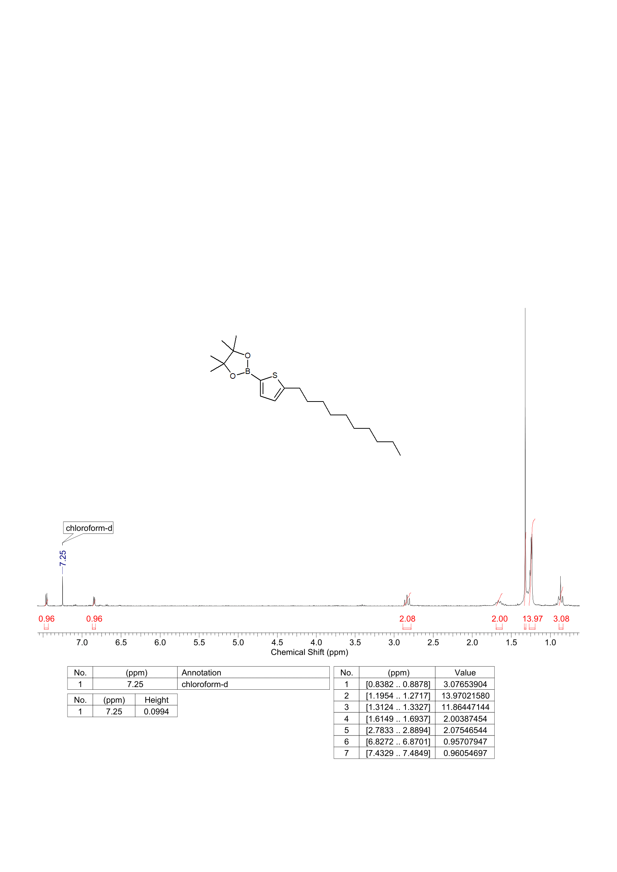

**Figure S4.** 1H NMR spectrum of **Dec-T-B-pin**.

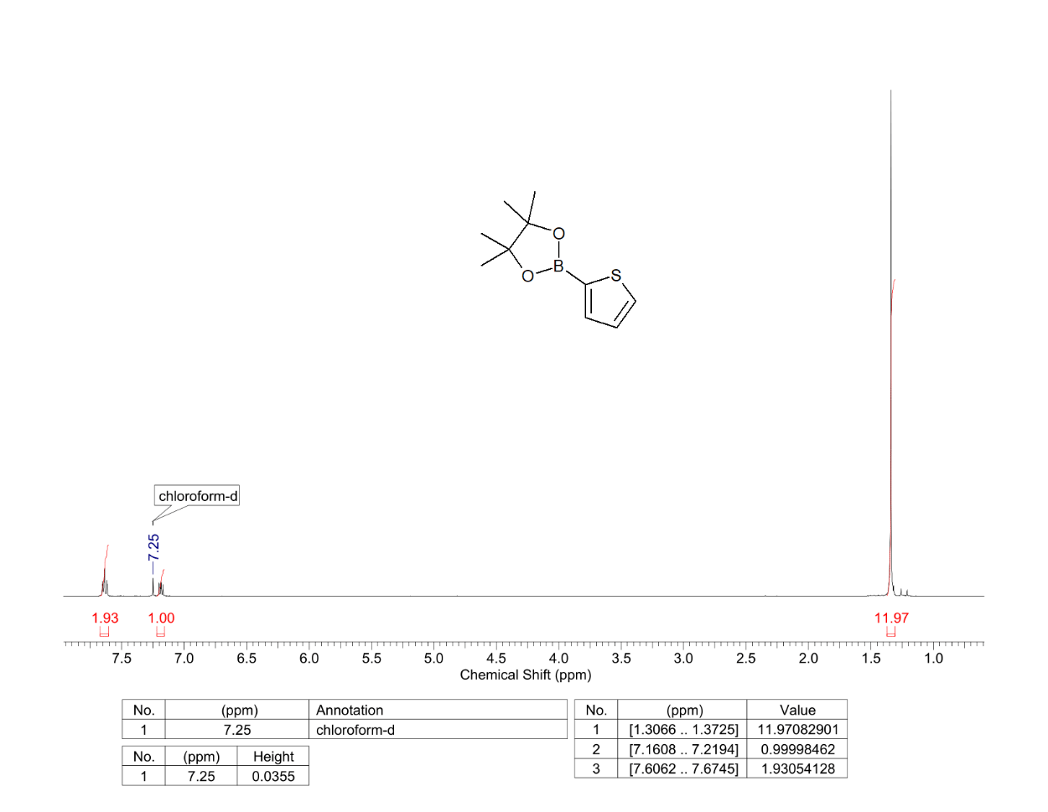

**Figure S5.** 1H NMR spectrum of **T-B-pin**.

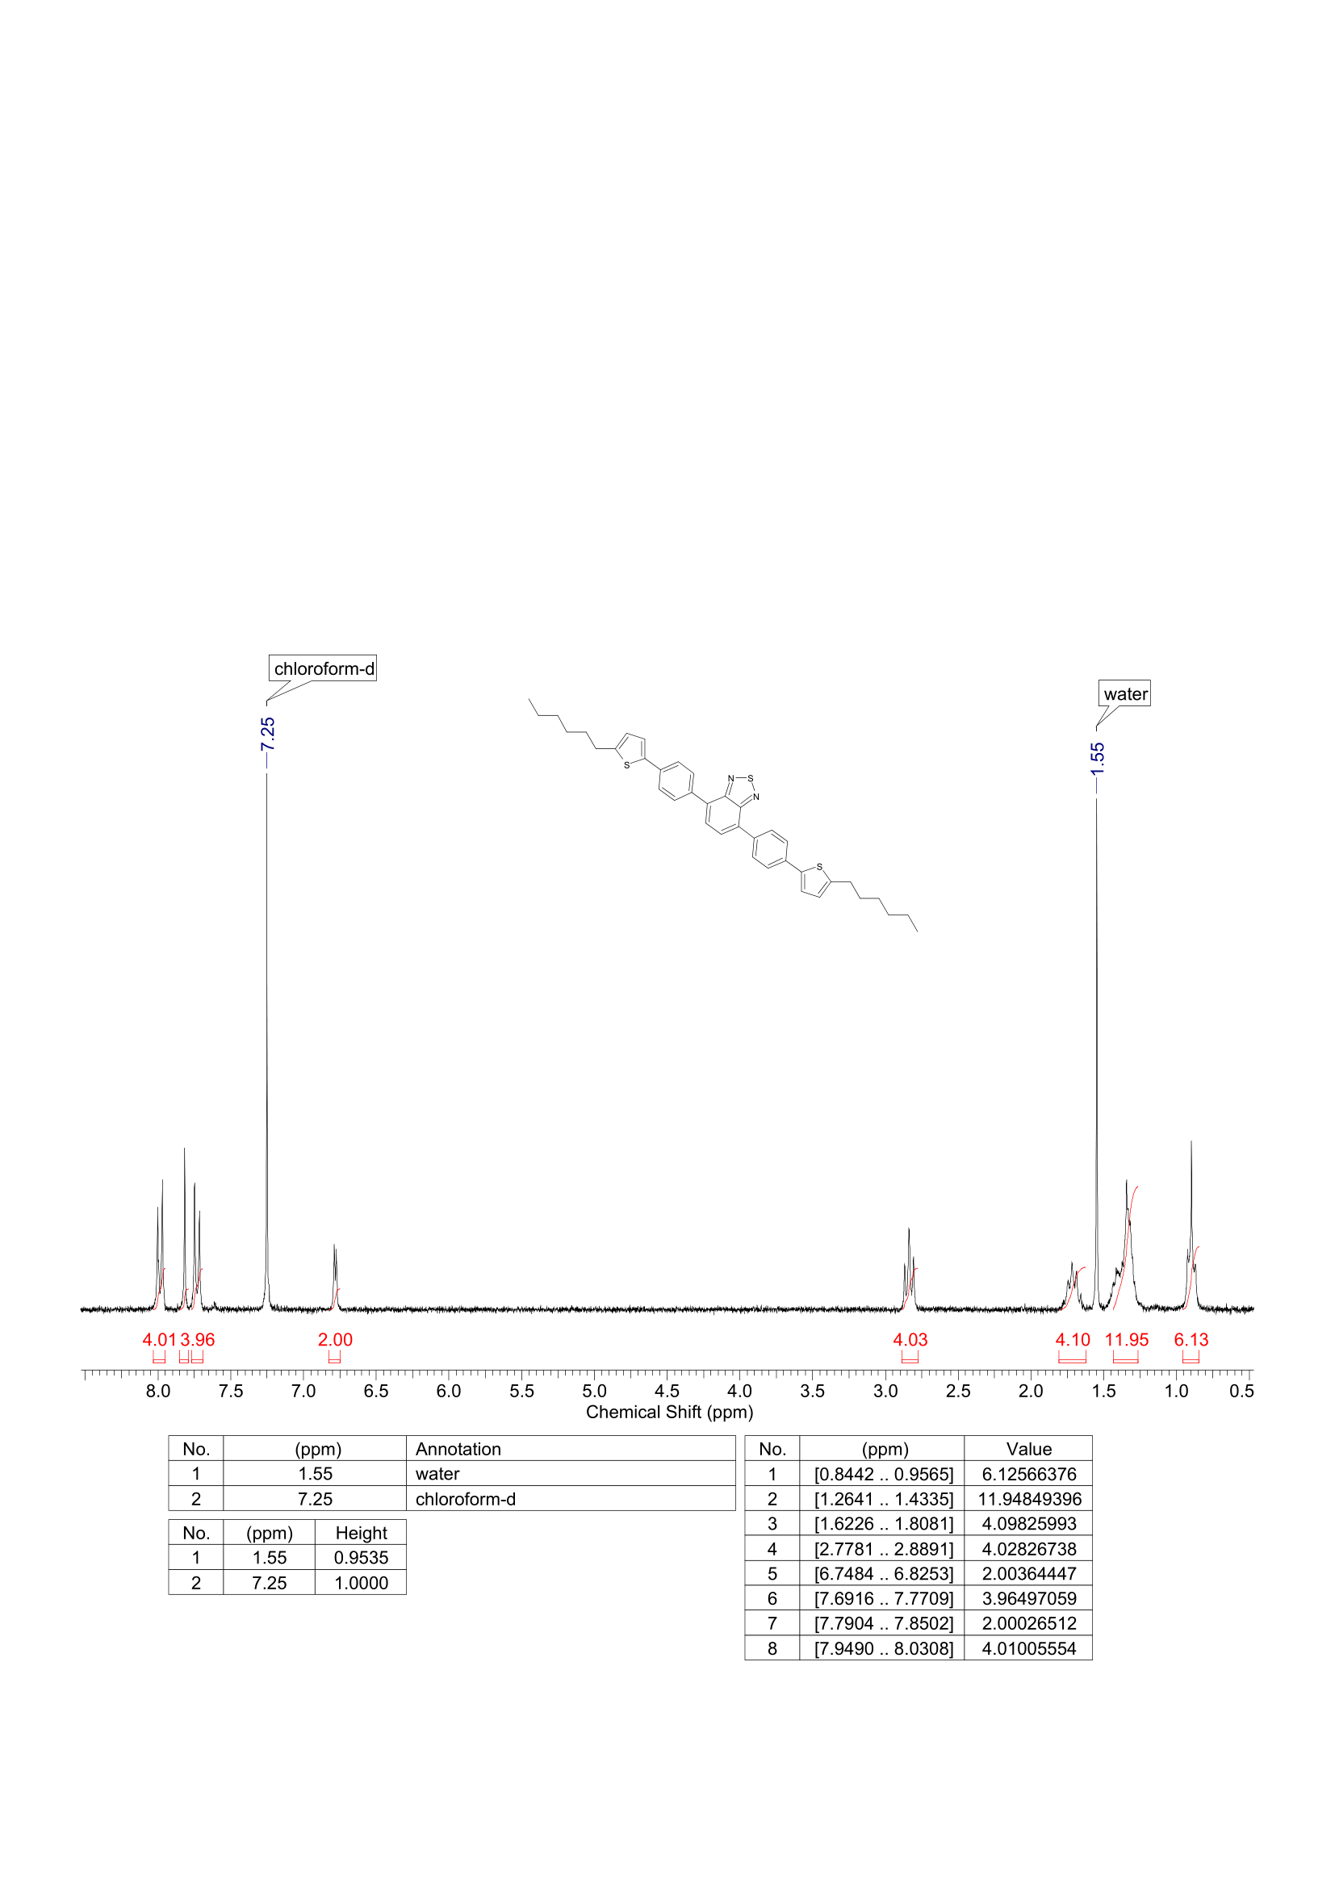

**Figure S6.** 1H NMR spectrum of **Hex-T-Ph-BTD**.

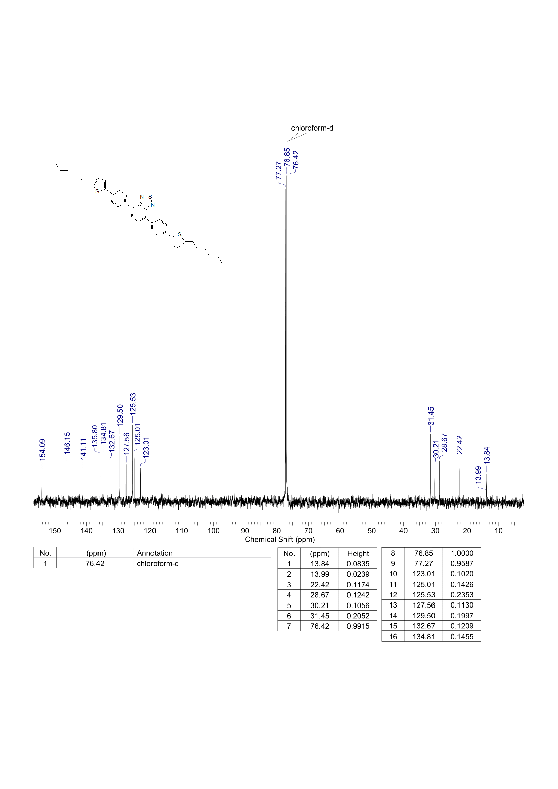

**Figure S7.** 13C NMR spectrum of **Hex-T-Ph-BTD**.

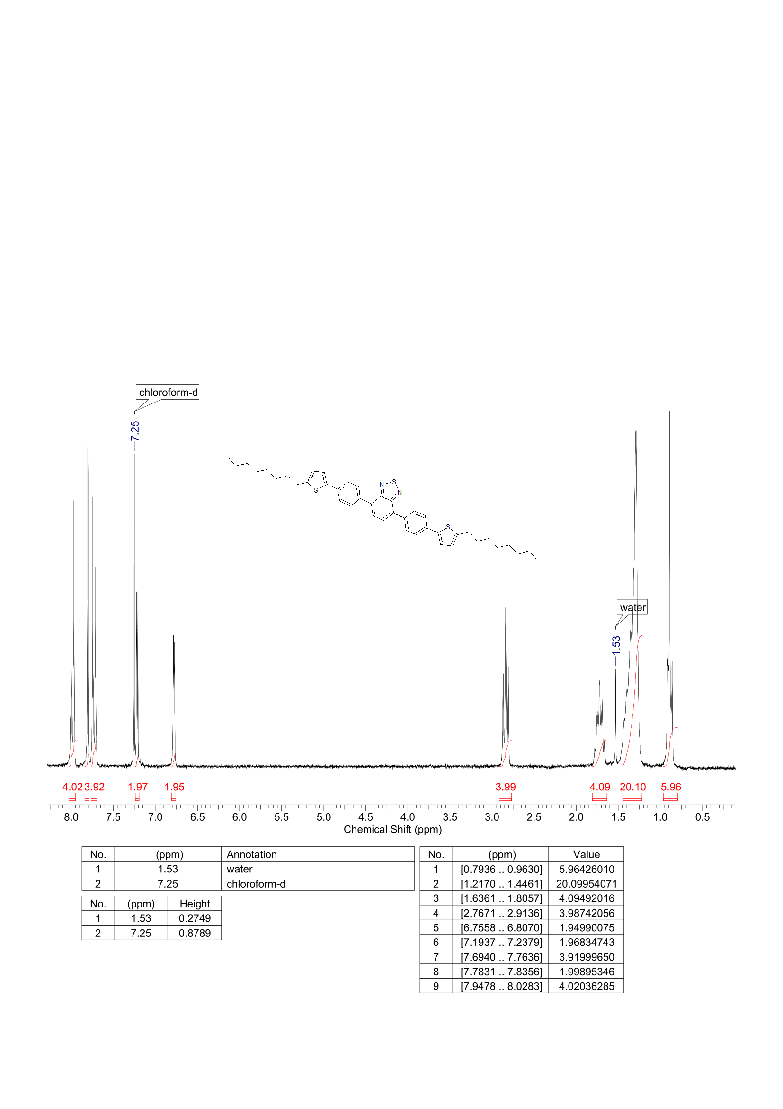

**Figure S8.** 1H NMR spectrum of **Oct-T-Ph-BTD**.

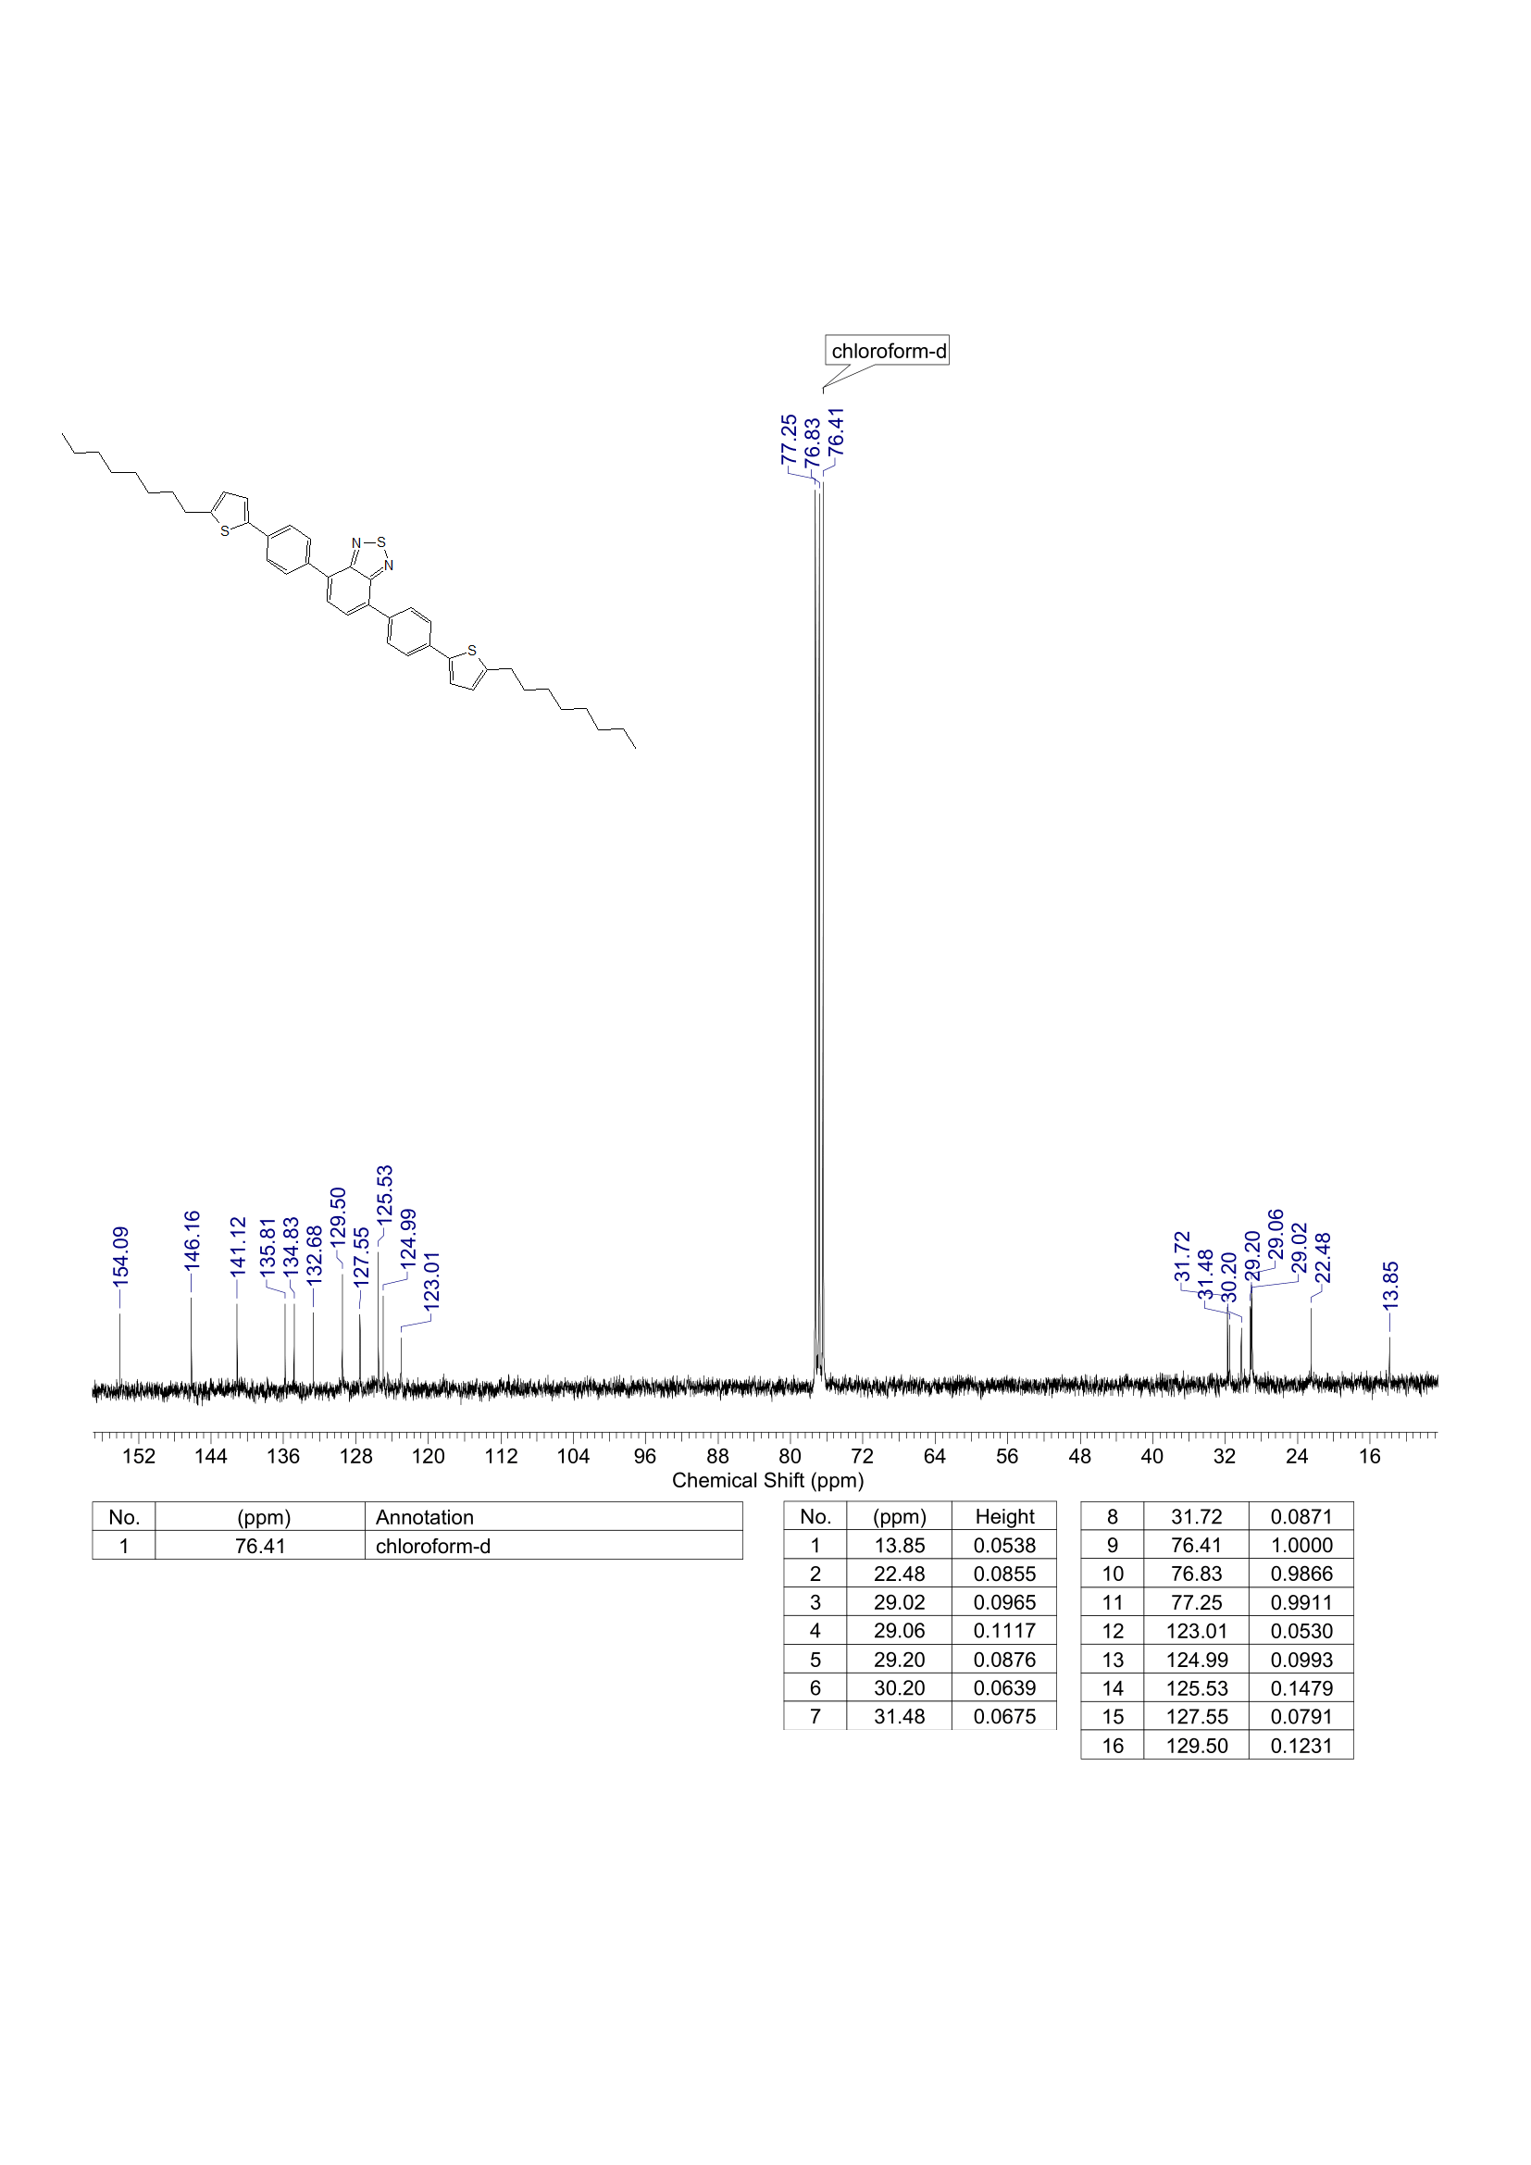

**Figure S9.** 13C NMR spectrum of **Oct-T-Ph-BTD**.

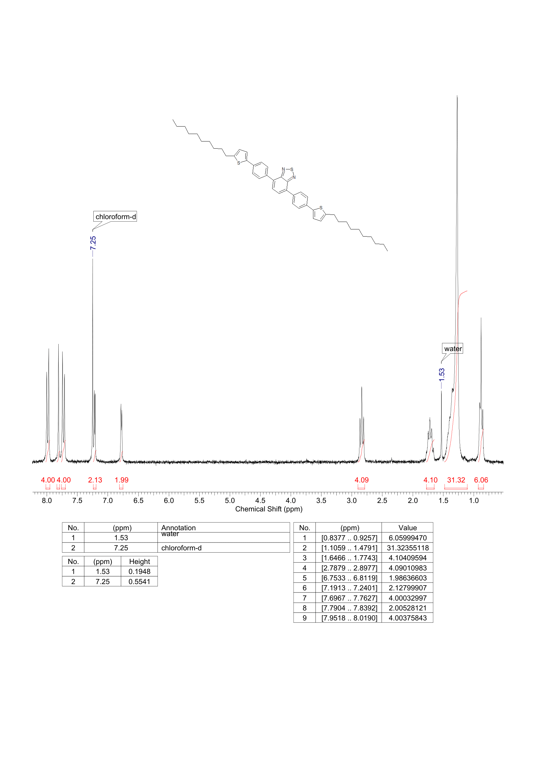

**Figure S10.** 1H NMR spectrum of **Dec-T-Ph-BTD**.

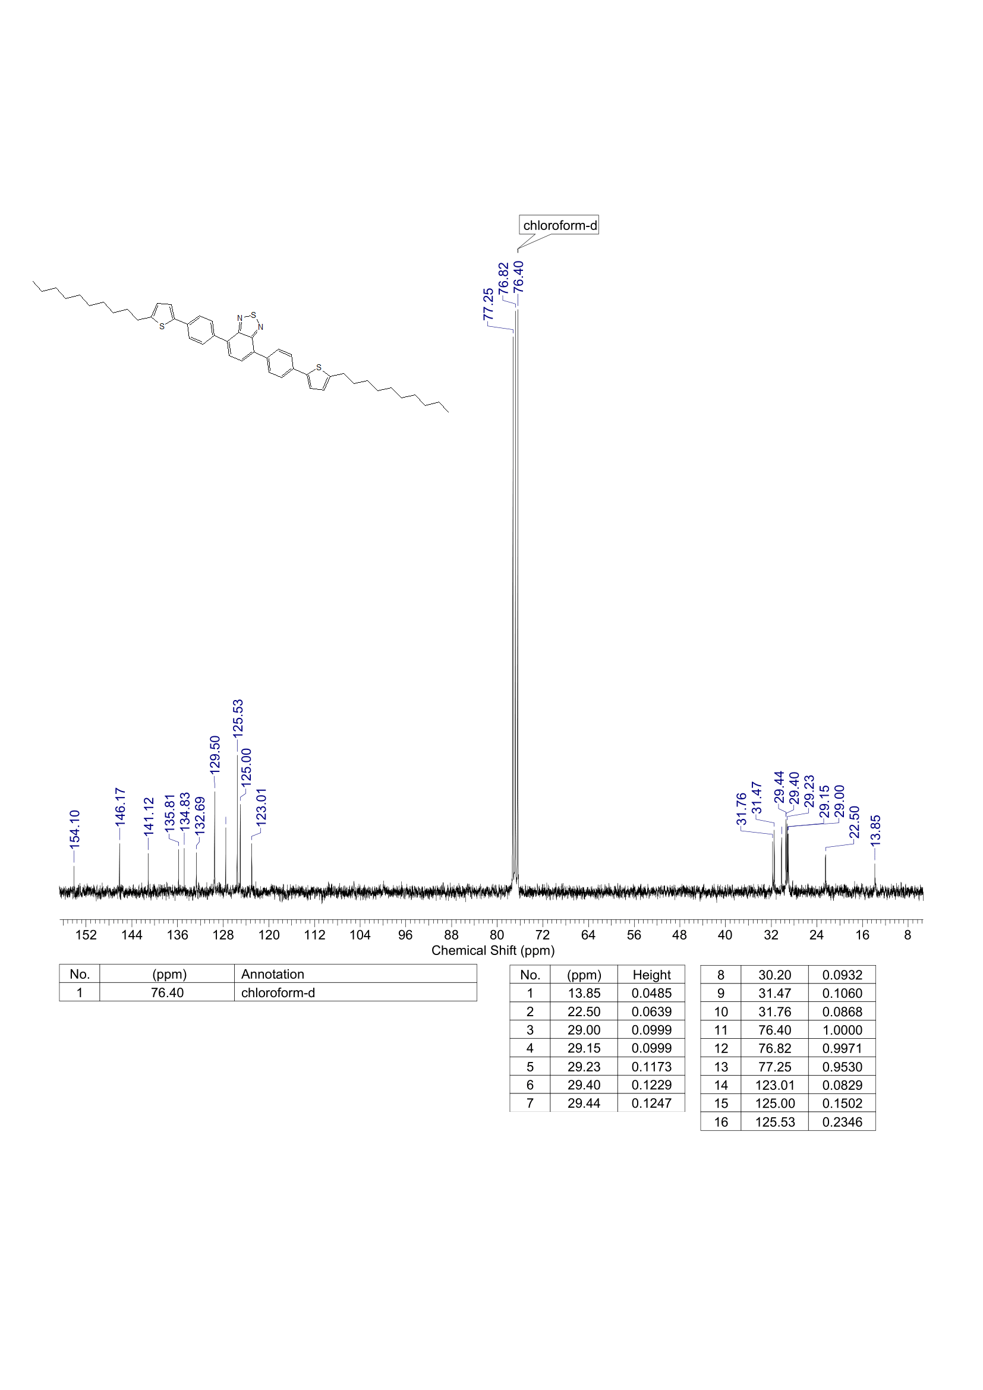

**Figure S11.** 13C NMR spectrum of **Dec-T-Ph-BTD**.

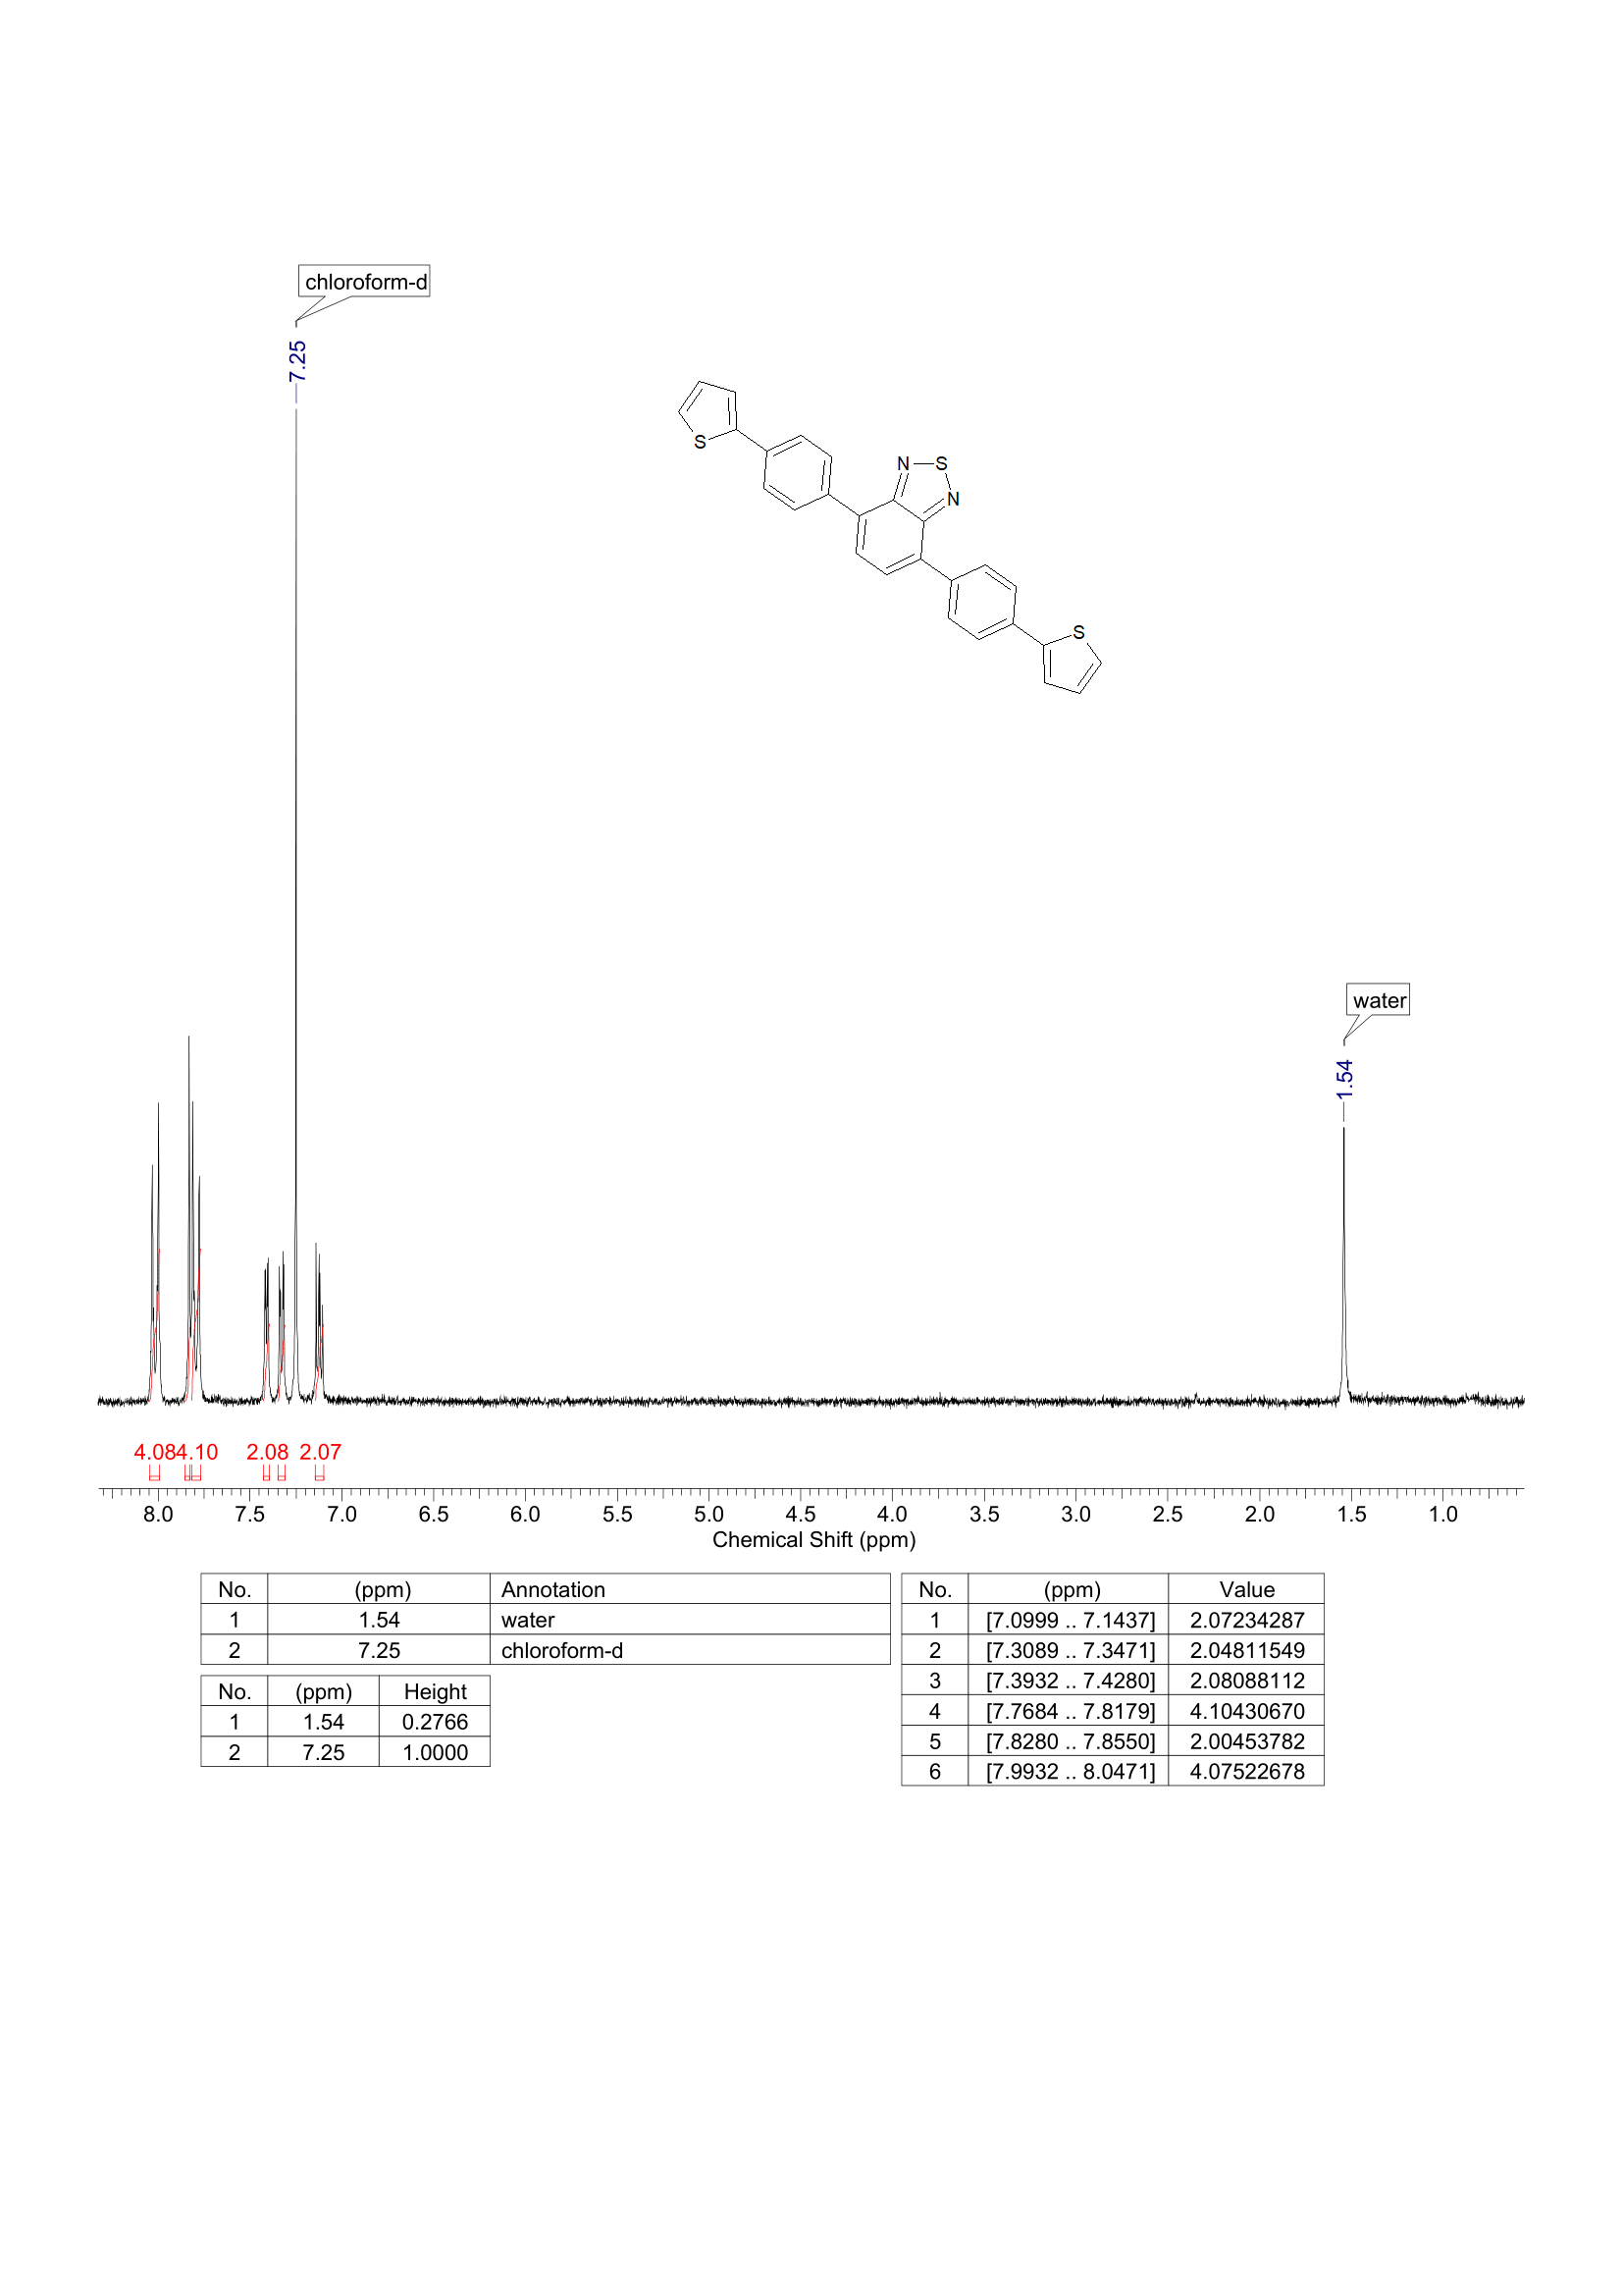

**Figure S12.** 1H NMR spectrum of **T-Ph-BTD**.

**3. Optical properties**

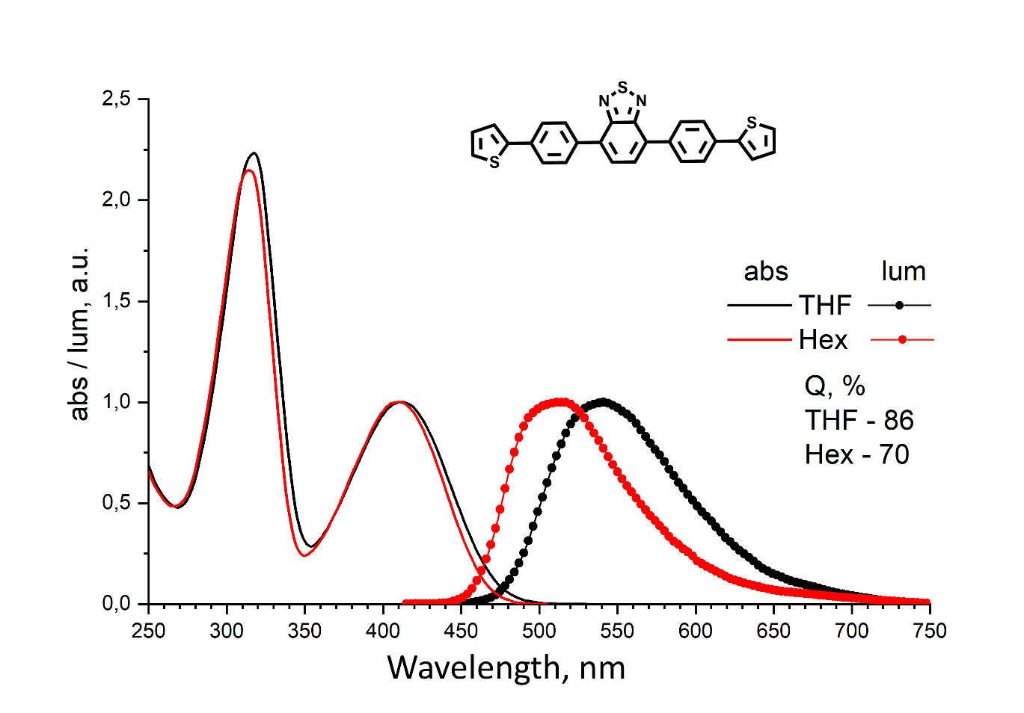

**Figure S13.** Absorption and luminescence spectra of **T-Ph-BTD**.

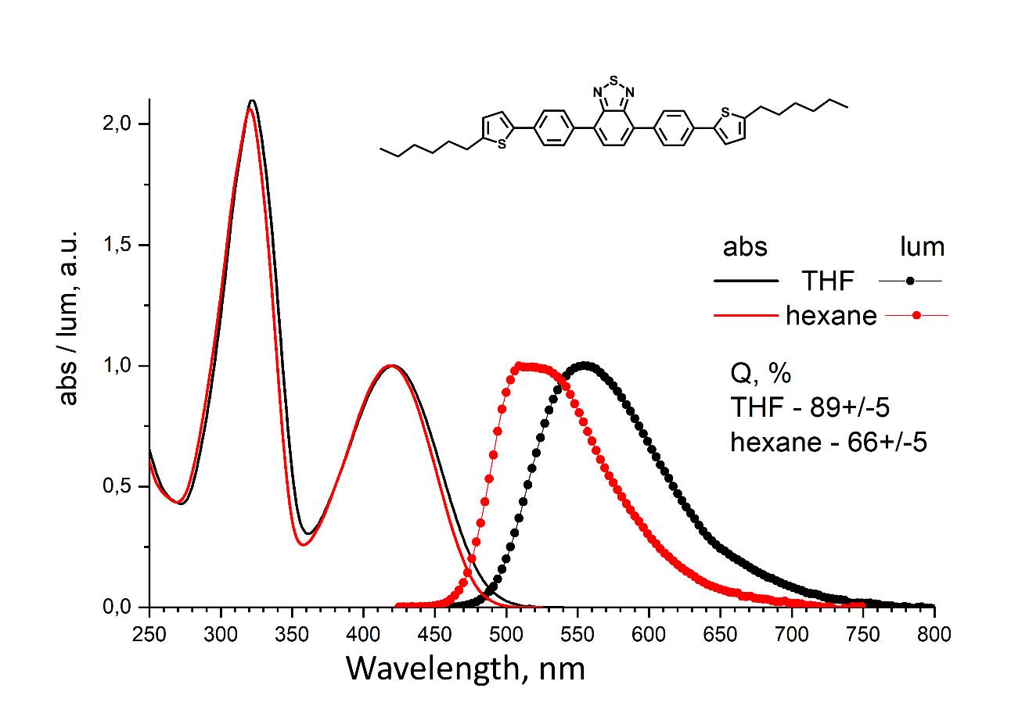

**Figure S14.** Absorption and luminescence spectra of **Hex-T-Ph-BTD**.

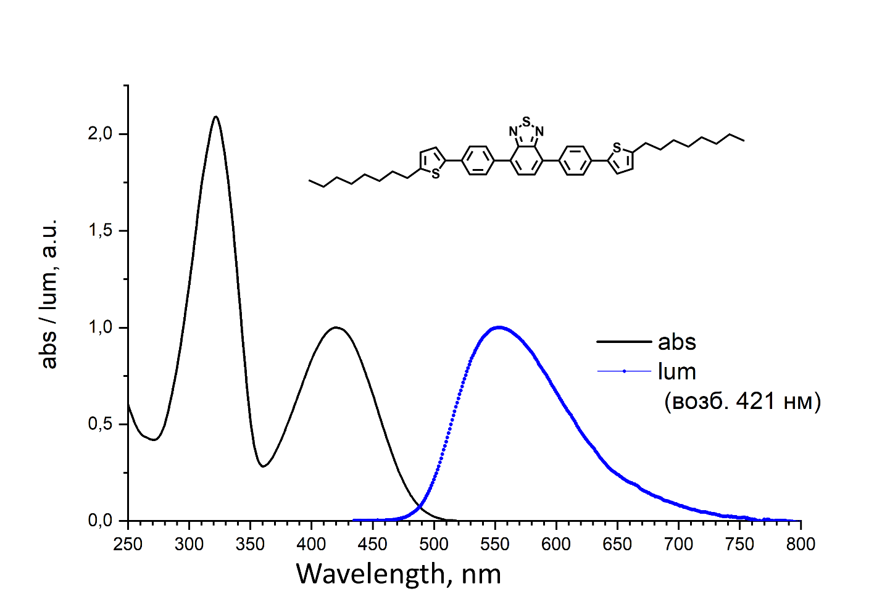

**Figure S15.** Absorption and luminescence spectra of **Oct-T-Ph-BTD**.

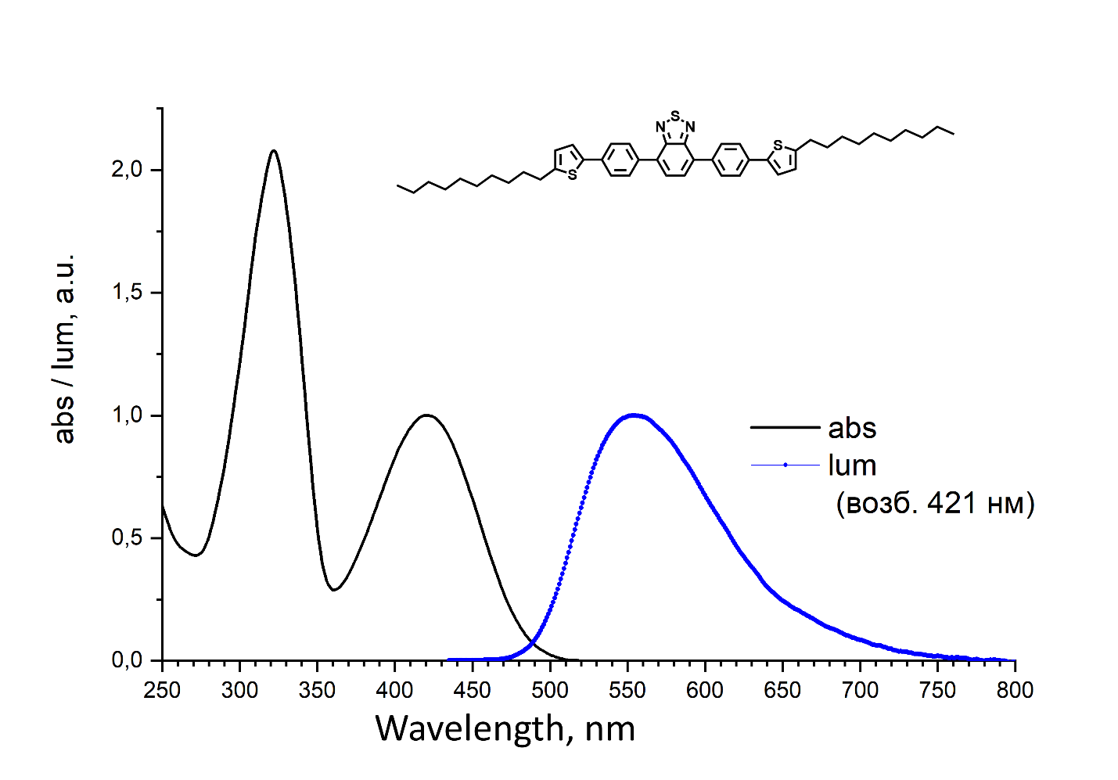

**Figure S16.** Absorption and luminescence spectra of **Dec-T-Ph-BTD**.

**4. Thermogravimetric analysis**

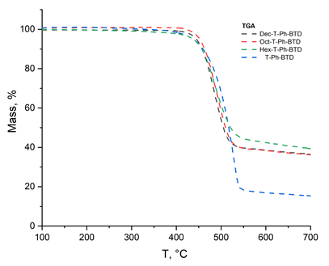

**Figure S17.** TGA curves for **R-T-Ph-BTD**.

**5. References**

S1. E. Shi, H. Zhuang, Z. Liu, X. Cheng, H. Hu, N. Li, D. Chen, Q. Xu, J. He, H. Li, J. Lu, J. Zheng, *Dyes Pigm.*, **2015**, *122*, 66–73. DOI: 10.1016/j.dyepig.2015.06.017

S2. W. Gao, Q. Luo, J. Wang, Y. Lin, C. Tang, J. Dou, H. Tan, Q. Zheng, C.-Q. Ma, Z. Cui, *Polym. Chem.*, **2017**, *8*, 1460–1476. DOI: 10.1039/C6PY02161A

S3. I. Wurzbach, C. Rothe, K. Bruchlos, S. Ludwigs, F. Giesselmann, *J. Mater. Chem. C*, **2019**, *7*, 2615–2624. DOI: 10.1039/c8tc04536d

S4. T. K. An, S. H. Jang, S.-O. Kim, J. Jang, J. Hwang, H. Cha, Y. R. Noh, S. B. Yoon, Y. J. Yoon, L. H. Kim, D. S. Chung, S.-K. Kwon, Y.-H. Kim, S.-G. Lee, C. E. Park, *Chem. Eur. J.*, **2013**, *19*, 14052–14060. DOI: 10.1002/chem.201302588

S5. M. Liu, X. Gong, C. Zheng, D. Gao, *Asian J. Org. Chem*., **2017**, *6*, 1903–1913. DOI: 10.1002/ajoc.201700441

S6. H. Kim, M. R. Reddy, H. Kim, D. Choi, C. Kim, S. Seo, *ChemPlusChem*, **2017**, *82*, 742–749. DOI: 10.1002/cplu.201700070